**CREATE AND USE REPOSITORY IN GITHUB**

**Aim**

To create and use a repository using github.

**Algorithm**

Step 1: Open the browser and search Github.com.



Step 2: Sign In to the website Then, the github will be displayed.

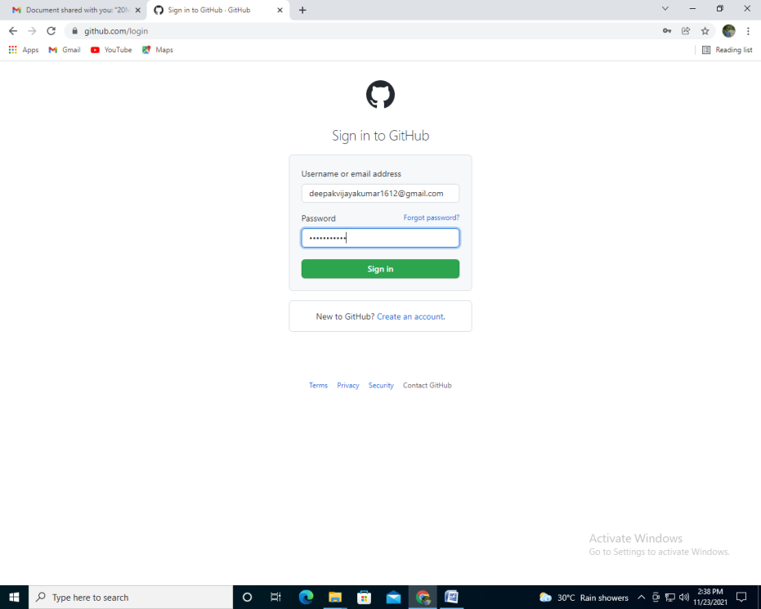

Step 3: Click the new in the left top corner.

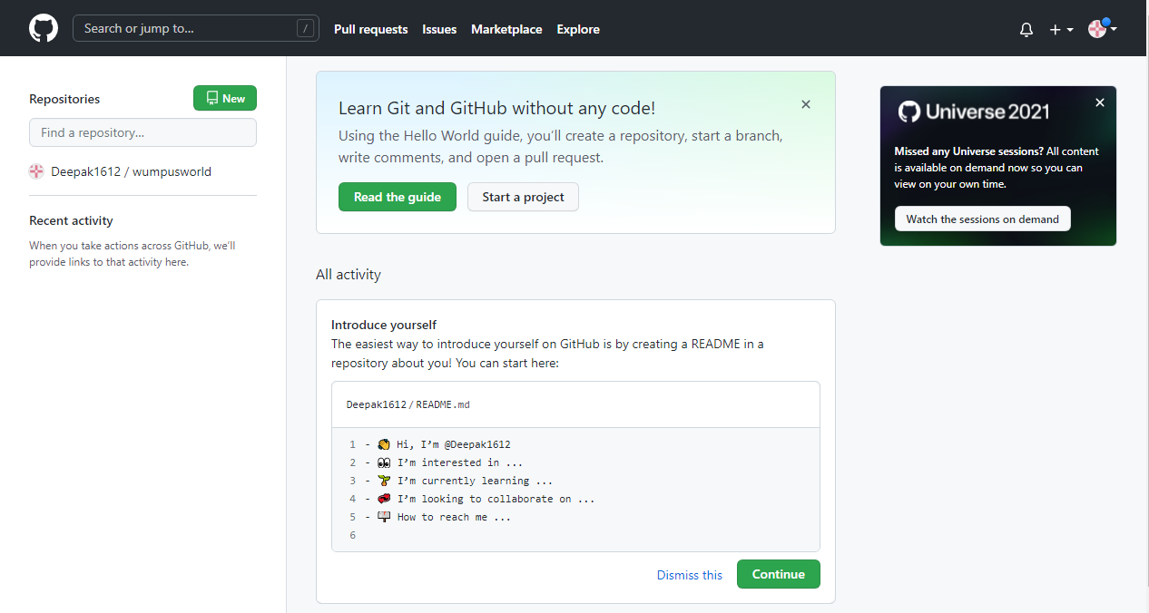

Step 4: Give the Repository name and make it as public

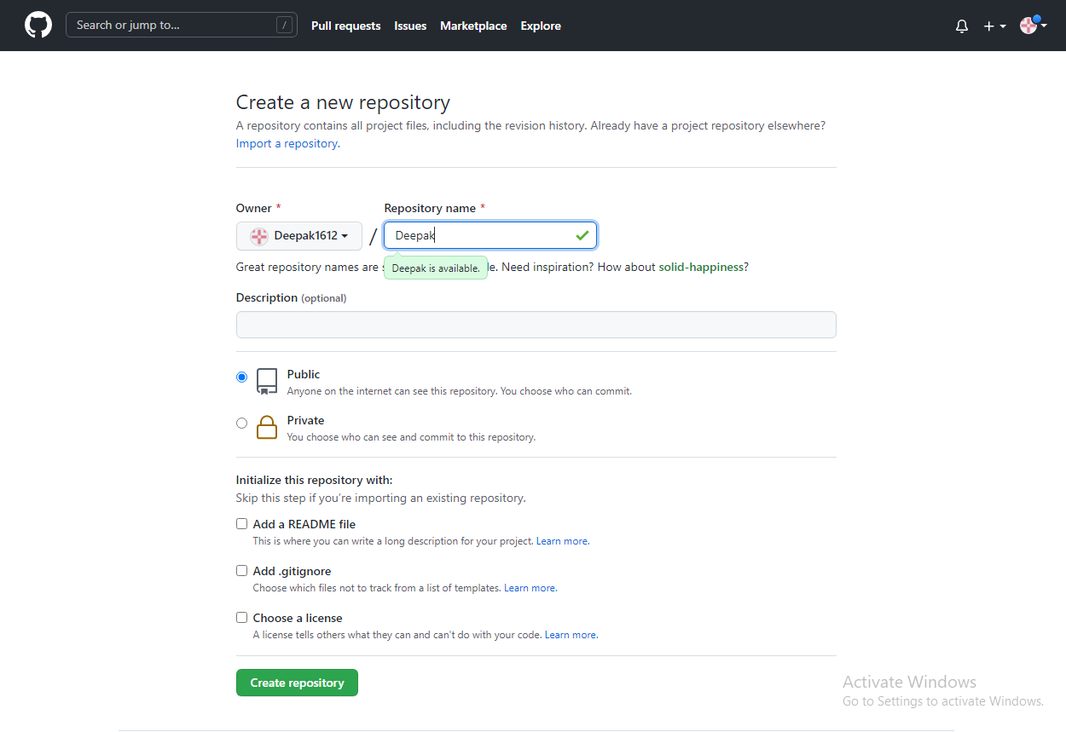

Step 5: Click create Repository.

Step 6 : Click the add file button. Click create file or upload file..

Step 7: Choose the file and upload it to github.

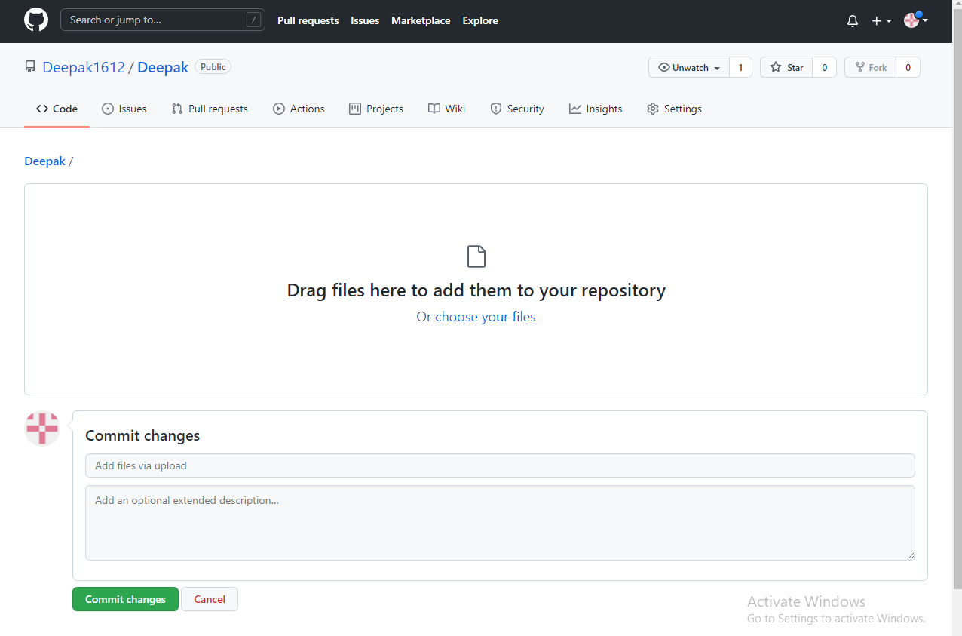

Step 8: Click the button and commit changes.

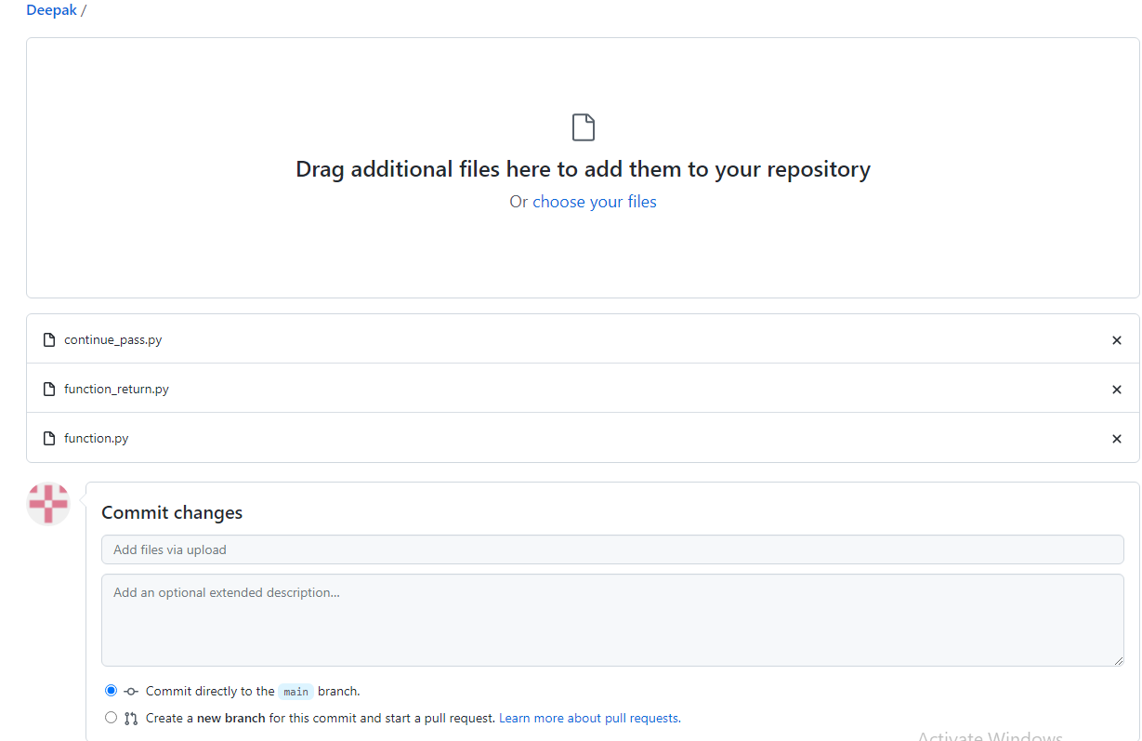

Step 9: The new repository is to be created.

